HOOVER
HIGH
SCHOOL

COURSE SELECTION
GUIDE
FOR
Ninth Grade

2013-2014

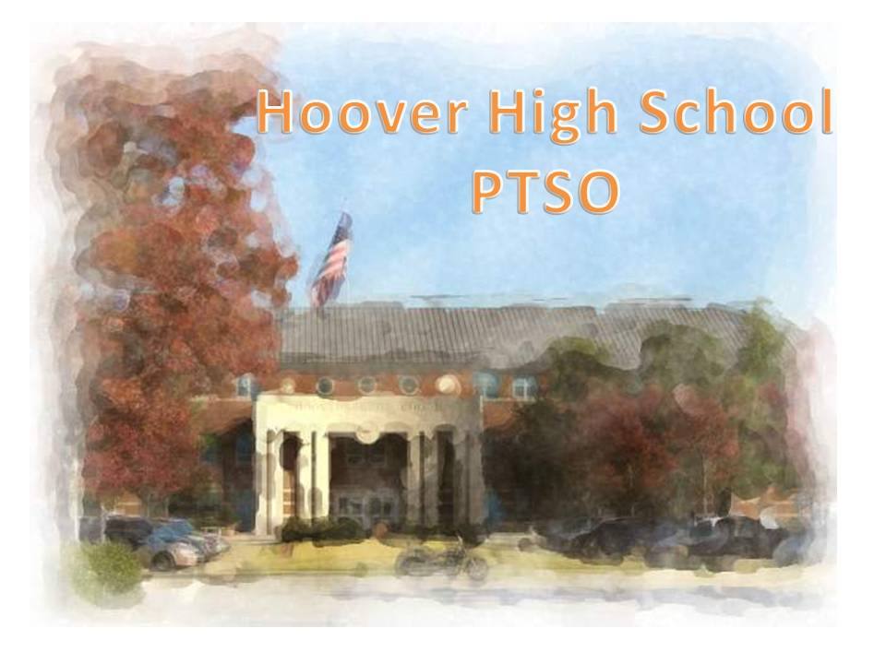
HOOVER HIGH SCHOOL
1000 Buccaneer Drive
Hoover, AL 35244
Telephone: (205) 439-1200
Fax: (205) 439-1201

PRINCIPAL DON HULIN
ASSOCIATE PRINCIPAL TERRY SMITH
ASSISTANT PRINCIPALS CARRIE BUSBY
CHARLES BUTLER
DR. HOLLY SUTHERLAND
JENNIFER HOGAN
JOHN MONTGOMERY
ATHLETIC DIRECTOR MYRA MILES
COUNSELORS DR. DEBBIE GRANT Ninth Grade A-L
MARLEY STEPHENS Ninth Grade M-Z
ANN HASTINGS Tenth Grade
ZACH BUTLER Eleventh Grade
PATTY PHILLIPS Twelfth Grade
COLLEGE/CAREER CINDY BOND
GRADUATION COACH LATANGELIA SANDERSON
SAP COUNSELOR JENNIFER MCCOMBS

THE MISSION, VISION, AND MOTTO OF HOOVER CITY SCHOOLS
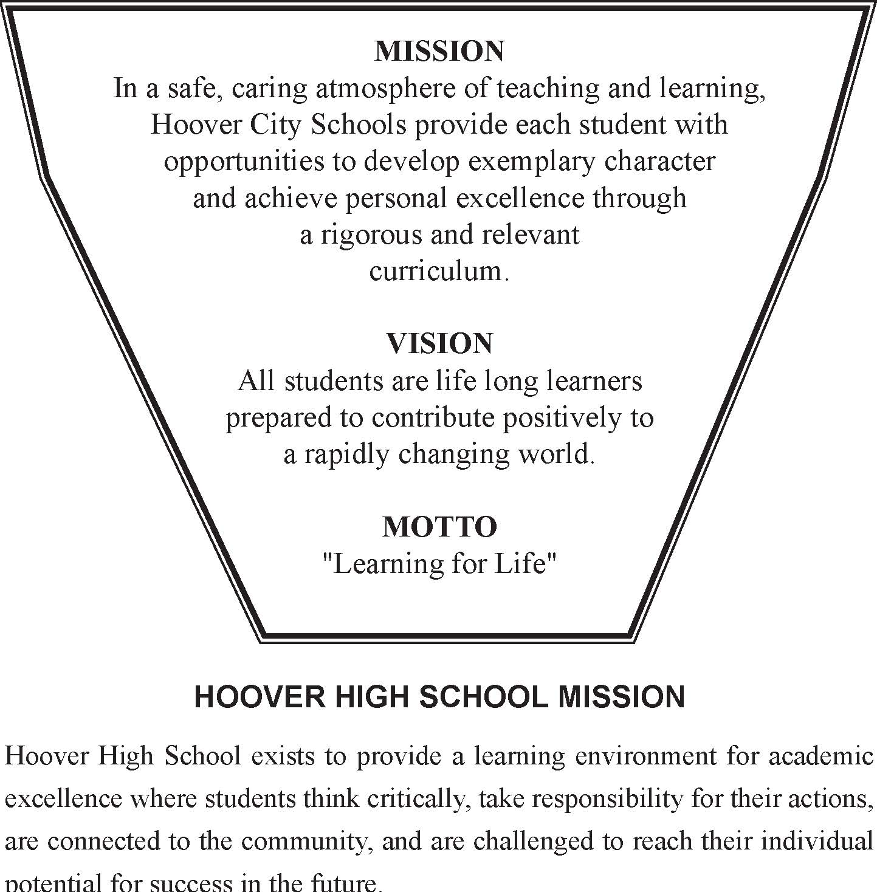
HOOVER HIGH SCHOOL BELIEFS
• Every student is valued and connected to the school community and supported as an individual in seeking education to attain personal goals and aspirations.
• Learning is enhanced when students think critically and take ownership/
personal responsibility for the process.
• Students learn best when challenged and actively engaged in relevant,
contextual, and meaningful activities.
• The best learning atmosphere is one in which student learning styles and teacher instructional styles are mutually acknowledged, enhanced, and encouraged.
• The instructional staff is organized to provide appropriate instruction to prepare students for their experiences in HIGH school and following graduation.

Notice of Nondiscrimination for all Mass-Distributed Publications/Mass Communication
Updated February 2013

EQUAL EDUCATIONAL OPPORTUNITIES

(Board policy, 6.6) No student will be unlawfully excluded from participation in, be denied the benefits
of, or be subjected to discrimination in any program or activity offered or sponsored by the Board on the
basis of race, ethnicity, color, disability, creed, national origin, sex, immigrant or migrant status, non-English speaking ability, or homeless status.
All career and technical education opportunities are offered
to all students regardless of race, color, national origin, sex, or disability. The district also provides equal
access to the Boy Scouts and other designated youth groups.
Dr. Barbara Mayer, IDEA Coordinator
Mrs. Marley Stephens, Section 504 Coordinator
Mrs. Linda Gurosky, Title I Coordinator
Dr. Deborah Camp, Title II Coordinator
Dr. Barbara Mayer, Title III Coordinator
Mrs. Melody Greene, Title IX Coordinator
Hoover City Schools
2810 Metropolitan Way
Hoover, AL 35243
(205) 439-1000

EQUAL EMPLOYMENT OPPORTUNITY
(Board policy, 5.13.1) The Board is an equal opportunity employer. Personnel actions and decisions will
be made without regard to factors or considerations prohibited by federal or state law (as such laws
may from time to time be amended), including but not limited to race, gender, age, disability, national
origin, citizenship, and religious preference. Subject to the limitations set forth in 4.6.2, the general
complaint (grievance) policy (4.6.1) may be used to present any complaint alleging unlawful
discrimination or harassment. Inquiries regarding compliance and complaint procedures can be directed
to:
Mary Veal, Equal Opportunity Employment Coordinator
Hoover City Schools
2810 Metropolitan Way
Hoover, AL 35243
(205) 439-1000

GENERAL INFORMATION
In choosing your courses each year it is important to keep several factors in mind.
• Look carefully at the prerequisites for courses you are interested in taking.
• Students who plan to apply to selective colleges and universities should have some advanced and/or AP courses during high school.
• Students need to research college and career opportunities and requirements for entrance early in their high school years.
• Computer skills are important to have in order to be successful in a number of courses in high school and college (papers, presentations, research).
The State Board of Education regulations require a specific number of hours of participation in a course in order to receive a Carnegie Unit of credit. At no time will a student be allowed to take a course considered less demanding when the student has completed a higher-level course in a sequence. Principals may approve course changes during the first ten days of school based on documented extenuating circumstances.
SCHEDULE CHANGE PROCESS
During the first ten days of the semester, the student must:
1. Sign up to see his/her guidance counselor to have the change approved;
2. Discuss the proposed change with his/her parent(s) and complete the
Drop/Add Parental Consent form available in counselors' office;
3. Pay $20 Drop/Add fee;
4. Return the fee receipt to the counselor;
5. Report to the office the day following the completion of step 4 to verify that the proposed change is possible and pick up the new schedule. Return textbook to teacher of the class leaving and obtain signature on the Drop/Add form. Upon receipt of a printed schedule, the transfer is considered official and the new schedule is in effect.
Keys to Success
(College and Careers Research Initiative Findings)
• Work Ethic
-a willingness to work hard
-ability to set and meet goals
-organization skills
-self-discipline
-ability to maintain focus and complete a task
• Written and Oral Communication Skills
-ability to communicate with a variety of people at different work levels or of different cultures
-ability to speak clearly and persuasively
• People Skills
-ability to get along with others
-ability to work as a member of a team
-ability to show empathy and compassion for others
• Thinking Skills
-logic, conceptualization, "common sense"
• Character
-integrity, honesty, ethics, trust
• Ability to Use Technology
PLANNINGYOUR HIGH SCHOOL CAREER

The goal of Hoover High School is to provide an educational program that will empower all students to make choices and meet the challenges of the 21st century. Each student will follow a series of steps in selecting courses for the coming year.
1. Students will meet with counselors in groups to discuss curriculum requirements.
2. Students and parents will study the course selection guide and make selections. Extreme care should be used in course selection since these selections have a direct bearing on post high school decisions. Consider academic strengths and weaknesses. Do you have career interests and are your course selections taking you in that direction? In what school and non-school extracurricular activities will you participate, and how will these affect your study time?
Consider these things:
- What are your plans after high school?
-. Are you going to a vocational school?
-. Are you going to a junior college?
-. Are you going to a four-year college?
-. Are you going into the work force?
-. Are you going into the military?

Parents should sign the registration sheet indicating approval of student choices.
3. Counselors and teachers are available to discuss selections with students.
4. Students and counselors discuss selections, notify parents of any changes, and request parent approval for changes.

GRADINGSYSTEM
The grading system at Hoover High School will reflect student’s actual performance in all facets of learning. The following grading system will be used:
90 - 100 = A
80 - 89 = B
70 - 79 = C
60 - 69 = D
Below 60 = F
Report cards will be issued at the conclusion of each 9-week grading period. Report card grades will list percentages as well as letter grades. The semester grade will be based on the value of 40% for each nine (9) weeks and 20% for the semester exam.

TESTS
PLAN
The PLAN is a test offered in the tenth grade to help students and their parents, teachers, and counselors with the comprehensive, detailed information they need to build solid education and career plans. It gives an early indication of readiness for the ACT Assessment. It contains academic tests that measure achievement in English, mathematics, reading, and science reasoning. Tenth graders will be given the opportunity to take the PLAN.

PSAT
The Preliminary Scholastic Aptitude Test/National Merit Scholar-ship Qualifying Test (PSAT/NMSQT) is a multiple choice test that measures verbal, mathematical reasoning, and writing abilities important to doing college work. It also includes a required writing section. The PSAT/NMSQT gives
students the opportunity to assess their verbal and mathematical skills, forecast SAT scores, discover whether they would be successful in Advanced
Placement courses, participate in the Student Search Service, and qualify for scholarship and enrichment programs (National Merit Scholarships, National Achievement Scholarships). It must be taken in a student's junior year to qualify for the awards provided by College Board. Sophomores will be given the opportunity to take the PSAT for additional practice.

SAT I Reasoning Test
The Scholastic Aptitude Tests are given to HIGH school juniors and seniors who plan to enter college. These tests are usually administered in October, November, December, January, April, May, and June. Preregistration is required. Register online at www.collegeboard.com or obtain a form from the Guidance Office.

ACT
The American College Tests are offered several times during the school year to students, usually 11th and 12th Graders, who plan to enter college. The months for testing are usually October, December, February, April, and June.
Preregistration is required and forms may be obtained from the Guidance Office. The ACT Assessment assists 11th and 12th Graders in the transition from HIGH school to postsecondary education by providing information that can be used for admission, course placement, advising, and planning. It is recommended to be taken in the late spring of a student's junior year, as much of the test is based on eleventh GRADE work. Register online at www.actstudent.org or obtain forms from the Guidance Office.

NATIONAL HONOR SOCIETY

Juniors and seniors with a 3.65 or higher cumulative GPA are eligible to be considered for membership in the Hoover HIGH School Chapter of National Honor Society. Those students who have met the GPA requirements will receive a letter inviting them to complete the selection process for membership. The four criteria used for membership are as follows: scholarship, leadership, service, and character. Once a student meets the scholarship requirements, he or she must further qualify in the areas of leadership, service, and character. This process will be outlined at a meeting of all those junior and senior students who are eligible for membership based on their meeting the scholarship requirements. Parents are encouraged to attend this meeting. Interviews will not be part of the selection process of the faculty council; therefore, it is imperative that each student completes the National Honor Society Information Sheet, which requires giving detailed information about a student’s involvement in the areas of character, leadership, and service. It is highly recommended that students devote adequate time and thought to this portion of the information sheet, and each candidate may want to request that the completed form be reviewed with a parent prior to being submitted. Along with scholarship requirements, a student’s final admission into the National Honor Society by the faculty council will be determined by the student-provided information contained in the information sheet and by teacher recommendations. All seniors (current members and those who apply for membership during their senior year) are required to take at least two of the following courses. (International Baccalaureate students following a prescribed IB curriculum are exempt from these requirements.)

AP Biology | Spanish 1*, 2, 3, 4 | AP Music Theory
AP Chemistry | Latin 1*, 2, 3, 4 | Calculus
AP Physics B or C | AP Spanish Language | AP Calculus AB
Human Biology | AP French Language | AP Calculus BC
Physics | Forensics Science | **AP Government and Economics
Genetics and Biotechnology | AP Latin Literature | AP Studio Art
AP Environmental Science | Math Team | AP Computer Science
AP English 12 | Pre-Calculus | AP Psychology
French 1*, 2, 3, 4 | Pre AP Pre-Calculus | Independent Research

*An additional first year language may be taken only if the student has successfully completed two years of a different foreign language. **AP Government and Economics count as one course

ADVANCED PLACEMENT
The Advanced Placement program is a nationally recognized program sponsored by The College Board which enables students to complete college-level studies while still in high school and to obtain college placement credit on the basis of their performance on rigorous Advanced Placement examinations. A strong Advanced Placement program depends upon a partnership between motivated students, of whom much is expected, and dedicated high school teachers who are trained by The College Board. Participation in Advanced Placement programs is often used as one of the criteria for academic scholarship and acceptance into many highly selective colleges. All Advanced Placement courses carry a course fee and the cost of the exam in the spring.
Advanced Placement courses move at a college pace and cover a wide range of content as defined by The College Board, that represent the same topics that one would expect to find in freshman and sophomore level courses at a typical college or university. Students should expect substantial reading and writing assignments outside of class, and on average an additional 30 minutes of homework

ASK YOUR COUNSELOR OR ADVANCED PLACEMENT TEACHER FOR ADDITIONAL INFORMATION.
INTERNATIONAL BACCALAUREATE PROGRAM

In 1996, Hoover High School became the fourth school in Alabama to affiliate with the International Baccalaureate Organization. This organization directs an international curriculum recognized by educators, colleges, and employers around the world as a standard of excellence. Since its inception 40 years ago, the IB program has become a symbol of academic integrity and intellectual promise. The student who completes the program demonstrates a strong commitment to learning, both in the mastery of subject content and the development of skills and discipline necessary for success in a competitive world.
The IB Curriculum is taught in the 11th and 12th grades. Before entering the 11th grade, students should have completed at least two years of Latin, Spanish, or French. Pre-IB English and Pre-IB History are strongly recommended for 9th and 10th graders considering entering the IB Program. Students sit for international examinations in all subjects at the completion of their study. If test scores are satisfactory and all IB requirements are met, students earn an International Baccalaureate Diploma in addition to Hoover High School's Advanced Academic Diploma.
Some basic facts about the IB program at Hoover High School are summarized below:
•Criteria - Students must earn passing grades in all Pre-IB or equivalent classes and maintain at least a “C” average overall to enter the IB program. Once beginning the IB Program, students must pass all classes and maintain at least a "C" average overall to remain in the program.
•Curriculum - The IB Diploma requires extended study in six academic areas or groups: English, Foreign Language, Social Studies, Mathematics, Science, and an IB-approved elective. See pages 16-17 for specific course requirements and options.
•Complements - In addition to the academic course work, IB students must complete an extended essay on a topic of the student's choice, 150 hours of community and Creative service, and a Theory of Knowledge course.
For further information on the International Baccalaureate program, contact the IB Coordinator at 439-1200

DUAL ENROLLMENT

The State Board of Education has adopted a policy which will allow eligible HIGH school students to enroll in college classes and to receive both HIGH
school and college credit for these classes. Hoover City Schools is currently engaged in a Dual Enrollment Plan with Jefferson State Community College and Lawson State Community College. Interested students should confer with their counselors.
Notice Dual Enrollment, Advanced Placement, International Baccalaureate, advanced classes, and some elective coursework may not be provided if a student is assigned to the Crossroads School.

Guide to Course Name Conventions Used at the High School Level

The terms listed below are used at the end of course titles to denote their special status. Course titles that do not contain these terms are considered part of the regular curriculum. The regular HIGH school curriculum of Hoover City Schools is based on a college preparatory model, and students should always expect challenging content and homework (an average of 15 – 30 minutes per night for each academic course). Homework should typically include respectful tasks that support, but do not replace, classroom instruction.

Pre-IB and Pre-AP courses are designations used by Hoover City Schools and are not authorized by the International Baccalaureate Organization or the College Board.

Pre-AP:

Description: Used to denote advanced level courses that specifically include content and skills that help prepare students for taking an Advanced Placement course in the given subject. These courses will also prepare students for the International Baccalaureate program in those subjects that do not have specific Pre-IB courses. The title Pre-AP designates a preparatory course for AP work, not a College Board Advanced Placement course.
Recommendation: Students with a strong work ethic who have demonstrated above average ability in the given subject and who desire to attempt college-level courses before graduating from high school
Content distinction: These courses cover more challenging topics by moving faster through the content
Grade weight: + 0.25 quality points

Pre-IB:
Description: Used to denote advanced level courses that specifically include content and skills that help prepare students for participation in the International Baccalaureate program.
Recommendation: Students with a strong work ethic who have demonstrated above average ability in all academic areas and who will have completed Algebra 2 w/Trig and at least two years of either French, Latin, or Spanish by the end of their sophomore year
Content distinction: These courses cover more challenging topics in greater depth, and they include content that is more focused on an international perspective to the given subject.
Grade weight:
Pre-IB English 10 — + 0.25 for parity with Pre-AP English 9 – 10
Pre-IB U.S. History 10 — + 1.00 for parity with AP U.S. History 10

AP:
Description: Used to describe college-level courses that follow the Advanced Placement curriculum as defined by The College Board that prepares students for an examination at the end of the course, and the scores from these exams can be submitted for consideration of credit to colleges or universities
Recommendation: Students with a very strong work ethic who are prepared to begin college-level coursework in the given subject prior to graduation from high school
Content distinction: These courses move at a college pace and cover a deep range of content as defined by The College Board that represents the same topics that one would expect to find in freshmen and sophomore level courses at a typical college or university
Homework load: These courses require substantial reading and writing assignments outside of class, and students should expect on average an additional 30 – 40 minutes of homework per night for each course
Grade weight: + 1.00 quality points
• Criteria: 85% average grade in advanced levels of the given subject and approval by the AP instructor

IB:
Description: Used to describe college-level courses that follow the International Baccalaureate curriculum as defined by the IB Organization in Geneva, Switzerland that prepares students for a series of examinations in all academic subjects, and the scores from these exams can be submitted for consideration of credit to colleges or universities
Recommendation: Students with a very strong work ethic who are prepared to begin college-level coursework in all academic areas prior to graduation from high school and who desire an international perspective in their education
Content distinction: These courses move at a college pace and cover a deep range of content as defined by the IB Organization that meets the standards of colleges and universities around the world as a benchmark of excellence
Homework load: These courses require substantial reading and writing assignments outside of class, and students should expect on average an additional 30 – 40 minutes of homework per night for each course
Grade weight: + 1.00 quality points
Criteria: Acceptance as an IB Diploma Candidate (approval of the IB Coordinator at HH

Team:
Description: Used to denote advanced level courses that are associated with academic teams that represent the school in competitive events
Recommendation: Students with a strong work ethic who have demonstrated superior ability in the given subject and who can commit to substantial time demands outside of the regular school day
Content distinction: These courses move even faster through the content than their Pre-AP/IB peers, and they use class time gained by the faster pace to practice for competition in the given subject
Homework load: On average, an additional 20 – 30 minutes per night for each course
Grade weight: + 0.50 quality points
Criteria: Approval of team sponsor

Dual:
Description: Used to denote courses that are associated with Dual Enrollment agreements that exist between Hoover City Schools and local colleges or universities
Recommendation: Students with a good work ethic who have demonstrated above average ability in the given subject and who wish to earn college and high school credit at the same time. Students must pay tuition to the college and receive permission from the principal to enroll in the dual enrollment course.
Content distinction: These courses follow the syllabus of the host college or university and may be taught on the high school or college campus
Homework load: Varies by the course, but typical of what would be expected in a college course
Grade weight: + 0.50 quality points
Criteria: Established by the college or university admission office (dual enrollment procedures)

LIBRARY

By serving as the information center for the school, the Library Media Center promotes the ideal of "Learning for Life" by providing access to information. The Library Media Center's balanced collection, services, and programs meet the diverse needs of our patrons and promote literacy among our users. The Library Media Program is critical to student academic achievement and success.

High School Consumable/Expendable Supply
Payment Schedule 2013-14

The following list of approved fees is approved for publication in course selection documents and student handbooks for the applicable academic year. Mandatory fees may not be charged for participation in curricular or co-curricular activities unless those fees are published in this schedule. The following statements should accompany any published list of required fees Miscellaneous supplies and materials such as paper, pencils, and novels will still need to be provided by the parent.
- Co-curricular activities such as band, athletics, choir, and academic teams may also require fund-raising activities.
- Mandatory fees will be waived for students who qualify for free or reduced lunch upon written request from a parent or guardian.
- Other parents who are concerned about fees or who need to set up a payment plan should request a conference with the principal.
- Where multiple fees might apply to the same course, such as an AP science class, the higher of the applicable fees will be the only one charged.

General Fees
Activity card (optional).............................................................................................................$60.00
Locker fee (optional, includes regular and PE locker if applicable).........................................$10.00
Parking fee (optional)................................................................................................................$25.00
Report card mailing fee...............................................................................................................$6.00
Schedule change request...........................................................................................................$20.00
Transcript fee (alumni only)........................................................................................................$5.00
(Alumni must also complete a personal information release form)

Academic Course Fees
Advanced Placement Exam Fee (Per Course)………………………………………………….85.00
Additional lab and supply fees may also apply. See the course guide for course specifics.
International Baccalaureate Program (per year, 11th and 12th)……………………………..$250.00
Science lab fee...........................................................................................................................$25.00
(excludes Active Physical Science, Biology, and Earth Science)

Elective Course Fees
Art Survey……………………………………………………………………...……..…...…..$10.00
Band, jazz ensemble..................................................................................................................$40.00
Band, marching (includes Aux Dance & Aux Flags)..............................................................$180.00
(includes course fee, uniform rental, and band camp participation)
Broadcasting courses.................................................................................................................$25.00
Business courses........................................................................................................................$25.00
Choir, piano keyboarding..........................................................................................................$25.00
Cooperative Education / Work Study (regular ed only)............................................................$15.00
Dance, all courses except Dance Team.....................................................................................$25.00
Drivers Education.....................................................................................................................$30.00
Engineering Academy...............................................................................................................$25.00
Family Consumer Science, …………………...........................................................................$25.00
Family Consumer Science, Foods & Nutrition ……................................................................$45.00
Finance Academy......................................................................................................................$25.00
Health Science Academy 1 - 3..................................................................................................$20.00
Health Science Internship..........................................................................................................$60.00
Information Technology Academy...........................................................................................$25.00
Law Academy...........................................................................................................................$15.00
Sports Medicine (1st year and Advanced)................................................................................$15.00
Strength & Conditioning (Athletes & Non-Athletes) ..............................................................$15.00
Team Sports .............................................................................................................................$15.00
Theater, all courses....................................................................................................................$15.00
US History Through Film…………………………………………………………………….$25.00
Visual Art, Ceramics / Sculpture / Creative Crafts................................................................$50.00
Visual Art, Digital Photography and Advanced Digital Photography.....................................$80.00
Visual Art, Photography.........................................................................................................$125.00
Visual Art, all others.................................................................................................................$40.00

Alabama High School Diploma (NEW)
Effective for incoming 9th grade, 2013-14

Areas of Study | Requirements | Credits
English Language Arts | English 9  English 10  English 11  English 12 | 4.0
Mathematics | Algebra 1  Geometry  Algebra 2 w/ Trig or Algebra 2 (or equivalent)  1 additional math course | 4.0
Science | Biology  A physical science (Physical Science, Chemistry, or Physics)  2 additional science courses | 4.0
Social Studies | World History 9  US History 10  US History 11  Government/Economics | 4.0
Physical Education | LIFE (Physical Fitness)  Band | 1.0
Health Education | Health Education | 0.5
Career Preparedness | Career Preparedness Course | 1.0
CTE /Foreign Language /Arts | Students choose any combination of Career Technical Education (i.e. academies, FCS, TV, computer and business), Arts Education, and/or Foreign Language courses | 3.0
Electives | Any other state or locally approved elective courses | 2.5
 | Total Credits Required for Graduation | 24

This one approach to the Alabama High School Diploma removes the need for endorsements or the Alabama Occupational Diploma. The focus will be on the coursework taken that necessitates a clearly articulated and individualized
four-year high school plan.

The EXPLORE academic and career interest assessment and middle school coursework are valuable resources when making course selections.

ENGLISH

English 9th grade 200005
Prerequisite: satisfactory completion of eighth grade English
Course Video:
http://www.youtube.com/watch?v=qELtx836cfs&utm_source=trigger&utm_medium=email&utm_campaign=you_tube_ready
English 9 includes a review of basic grammar skills, composition and writing, literature study, and a vocabulary program incorporating Greek and Latin root words as well as vocabulary development for high stakes testing instruments. Students are introduced to the library facilities and are required to complete an informational research paper in addition to other modes of writing.

English 9th grade, Pre-AP 200007
Prerequisite: EXPLORE English score 15+, Reading score 17+
Course Video: http://www.youtube.com/watch?v=1fEH8nlc4ZA
In addition to regular course of study, English 9, Pre-AP emphasizes critical thinking skills, literary analysis, formal essay writing, both timed and untimed, as well as group discussions and presentations. Students are also introduced to timed multiple choice simulations of adapted AP testing instruments. Traditional and contemporary literary works are evaluated. This course moves at a rapid pace and is geared towards above-average readers, competent writers, and well-motivated, independent learners. It is aligned with The College Board Advanced Placement standards and assessments in ways that are appropriate expectations and challenges for ninth grade students. Students enrolling in English 9, Pre-AP are those who anticipate enrolling in AP programs as juniors or seniors. The title Pre-AP designates a preparatory course for AP work, not a College Board Advanced Placement course.

PRE-IB ENGLISH 9th GRADE 2000071
Prerequisite: EXPLORE English score 15+, Reading score 17+
Course Video: http://www.youtube.com/watch?v=BdO3dKHQwD8&feature=youtu.be
This course is taken by ninth grade students who anticipate enrollment in the eleventh grade as IB Diploma Candidates. This course will follow the basic form of other advanced academic English classes, but will include works from world literature, additional writing instruction, and evaluation criteria based on the IB assessment standards. The Pre IB history and English courses are intended to be studied across disciplines and should be taken concurrently.

SOCIAL STUDIES

WORLD HISTORY SINCE 1500, 9TH GRADE 230013
Grade Level: 9
Course Video:
This course explores historical development from 1500 to the present, concentrating on the personalities, the ideas, and the events that have shaped the modern era in Europe, the Western world, Africa, and Asia. Geographic impact, development of civic knowledge/responsibilities, and emerging economic systems within a chronological context will be emphasized.

WORLD HISTORY SINCE 1500, PRE-AP 230015
Grade Level: 9
Prerequisite: EXPLORE Reading score 18+
Course Video: http://www.youtube.com/watch?v=BDia2qCo3H4
This course explores the same topics as World History since 1500 but has a higher emphasis on critical thinking and examination of historical texts. The title Pre-AP designates a preparatory course for AP work, not a college Board Advanced Placement course.

WORLD HISTORY SINCE 1500, PREIB 2300151
Grade Level: 9
Prerequisite: EXPLORE Reading score 18+
Course Video: http://www.youtube.com/watch?v=YHFfdfyJSJM
This course is taken by ninth grade students who anticipate enrollment in the eleventh grade as IB Diploma Candidates. This course explores the same topics as World History since 1500 but has a higher emphasis on critical thinking and examination of historical texts. The Pre IB history and English courses are intended to be studied across disciplines and should be taken concurrently.

S C I E N C E

BIOLOGY 220011
Grade Level: 9
Course Video: http://youtu.be/eY5SsYtAd28
Biology introduces students to the basic principles of life such as cellular organization, genetics, and comparative structures in various phyla. This course is intended to meet the science literacy requirements of the Biology core curriculum as defined by the state science course of study. This course also requires laboratory work written in formal laboratory reports as well as an independent research-based project component.

BIOLOGY, Pre-AP 220013
Grade Level: 9
Prerequisite: EXPLORE Science score 22+, Reading score 17+
Laboratory Fee: $25
Course Video: http://youtu.be/eY5SsYtAd28
The Biology, Pre-AP course is designed to prepare students for success in Advanced Placement science courses. In preparation for these courses, pre-AP biology students will be required to complete reading assignments outside of class related to scientific articles and/or scientific literature and complete independent research-based projects each nine weeks. Students should be good readers with strong comprehension skills. Students will also be required to write formal lab reports and analyze scientific data throughout the course. Finally, a major form of assessment in the pre-AP classroom will be writing essays to explain scientific concepts in preparation for the Advanced Placement examinations. The title Pre-AP designates a preparatory course for AP work, not a College Board Advanced Placement course.

M A T H E M A T I C S

Algebra I 210005
Grade Level: 9
Prerequisite: 70% in 8th grade Math and Teacher recommendation
Algebra I introduces algebraic concepts dealing with the real number system, its properties and operations. Emphasis is on factoring, graphing linear equations, simplifying and evaluating expressions, performing operations on polynomials and rational expressions, inequalities, equations, systems of equations, quadratic and rational equations. Other topics include probability and statistics, functions, and relations

Algebra I, Pre-AP (+.25 grade weight) 210007
Grade Level: 9
Prerequisite: 90% in 8th Grade Math and Teacher recommendation
Course Guide: http://youtu.be/VTFDwOay4hk
Pre-AP Algebra I uses advanced algebraic concepts dealing with the real number system, its properties and operations. Emphasis is on factoring, graphing equations, simplifying and evaluating expressions, performing operations on polynomials and rational expressions, inequalities, equations, systems of equations, quadratic and rational equations. Other topics include probability and statistics, functions, and relations. Complex algebraic concepts will be explored and emphasized.

Algebra 1-A (2 consecutive periods) 210008
Prerequisite: below 70% in 8th grade math and Teacher recommendation
Course Video: http://www.youtube.com/watch?v=BxEBjfLTRhA
Algebra 1-A is a one semester class that will earn one math credit. This course teaches simultaneous concepts that are being introduced and mastered in the first semester of regular Algebra I classroom. The course provides the student with more extensive instruction on course content and provides additional opportunities for the delivery of instructional content.

Algebra I-B (2 consecutive periods) 210009
Grade Level: 9
Prerequisite: Algebra I-A and Teacher recommendation
Course Video: http://www.youtube.com/watch?v=BxEBjfLTRhA
Algebra 1-B is a one semester class that will earn one math credit. This course teaches simultaneous concepts that are being introduced and mastered in the second semester of regular Algebra I classroom. The course provides the student with more extensive instruction on course content and provides additional opportunities for the delivery of instructional content.

Geometry 210010
Grade Level: 9-11
Prerequisite: EXPLORE Math score 17+ or 70% in Algebra 1 and Teacher recommendation
Course Video: http://www.youtube.com/watch?v=rRtDul1G67Q
Geometry presents a logical development of the basic concepts and understanding of Euclidean geometry. Included in this course are topics from plane geometry, solid geometry and coordinate geometry. The geometry course requires students to make conjectures and use reasoning to validate or negate these conjectures. Concepts and skills involve deductive reasoning taught through the use of direct and indirect proofs. Topics include angles, parallel lines, triangles, special right triangles, Pythagorean Theorem, polygons, circles, area, volume, transformations.

Geometry, Pre-AP (+.25 grade weight) 210012
Grade Level: 9-10
Prerequisite: EXPLORE Math score 19+ or 90% average in Algebra I and Teacher recommendation
Course Video: http://www.youtube.com/watch?v=W20FtBoAinA
This course covers the same topics as geometry with a more in-depth and challenging analysis of the major concepts and more emphasis on theory. Logical thinking is developed through concentration on direct and indirect proofs. This course is geared to the motivated student who plans to enroll in a Math Advanced Placement course in the future. The title “Pre-AP” designates a preparatory course for AP work, not a College Board Advanced Placement course.

Geometry, Math Team (+.50 grade weight) 2100125
Prerequisite: Algebra 1
Grade Level: 9
Required Signature: Teacher Recommendation
Fee: Fundraiser/$150
Course Selection: http://www.youtube.com/watch?v=sCFB0P0V7Rs
This course consists of an enriched and accelerated geometry course. First semester content includes most of the standard topics for the year excluding formal proofs. Short cuts, formulas, and test taking skills are supplemental. Second semester includes proofs, analysis, problem solving techniques, and introductory Algebra 2 topics.

REQUIRED ELECTIVES

CAREER PREPAREDNESS 400025
Grade Level: 9
This one credit course prepares students with content knowledge and skills in the areas of career development and academic planning, computer skill application, and financial literacy. This course meets the 20 hour online experience requirement.

Any one of the following courses meets the Physical Education Requirement:

BAND CONCERT/MARCHING 280035
Prerequisite: Permission of instructor and prior instrumental music instruction required. No beginning instruction is available. Each musician will be expected to perform at a Grade 3 level of musicianship to participate in the band. Concert and Marching instruction is provided for each student. Band is divided into 2 or 3 class levels (depending on total enrollment) which is determined by audition prior to enrollment. Students must be in band both semesters. Attendance at all rehearsals and performances is required and graded. Director's signature is required on course selection sheet.
Fee:$180
Course Video: http://www.youtube.com/watch?v=YFBWkJ6yeHE
Marching band will provide musical and visual entertainment at all football games. In addition, students will participate in competitive events such as marching festivals and contests. Concert bands will perform winter and spring concerts and will participate in District and State assessment performances. Major areas of concentration are as follows: development of characteristic tone production, playing fundamentals, and marching fundamentals. This course meets the Physical Education requirement and additionally the Fine Arts requirement.

PHYSICAL EDUCATION/ LIFE COURSE 240002
Course Video: http://www.youtube.com/watch?v=eGqNurlyWSw
All 9th graders will be required to take the LIFE course. LIFE stands for Lifelong Individualized Fitness Education. This course provides students with the opportunity to develop an individual level of fitness, acquire knowledge of fitness concepts, and understand the significance of a healthy lifestyle.

PHYSICAL EDUCATION, ATHLETIC LIFE COURSE, BOYS 2400021
Course Video: http://www.youtube.com/watch?v=0zOmxRqYNz8&feature=youtu.be
This course is for students who are on a Hoover athletic team. The course offers advanced skills in strength training and conditioning as well as covering the concepts required by the state course of study for the LIFE course. This course requires a signature and permission of the instructor/coach.
PHYSICAL EDUCATION, ATHLETIC LIFE COURSE, GIRLS 2400022
Course Video: http://www.youtube.com/watch?v=0zOmxRqYNz8&feature=youtu.be
This course is for students who are on a Hoover athletic team. The course offers advanced skills in strength training and conditioning as well as covering the concepts required by the state course of study for the LIFE course. This course requires a signature and permission of the instructor/coach.

FOREIGN LANGUAGE

SPANISH

SPANISH 1 270153
Course Video: http://www.youtube.com/watch?v=oSyWL60bADE
In Spanish 1, the student will acquire a basic vocabulary for reading, writing, and conversation. The past and present tenses of verbs will be learned. The student will begin to learn about the civilization and culture of the Hispanic countries.
SPANISH 2 270154
Prerequisite: Spanish I
Course Video: http://www.youtube.com/watch?v=LI2mKCjlHEI
Spanish 2 builds on the foundation of Spanish 1. Students will learn additional verb tenses and increase their vocabulary. Students will continue to develop their listening, writing, reading, and speaking skills. The study of Hispanic culture is a component of the course. This course is intended for students that will end their study of Spanish with Spanish 2.

SPANISH 2 Advanced 2701541
Prerequisite: Spanish I
Course Video: http://www.youtube.com/watch?v=yXkxGqVoTx8&list=HL1357929614
Spanish 2 builds on the foundation of Spanish 1. Students will learn additional verb tenses and increase their vocabulary. The Advanced course is taught at an accelerated pace allowing students to greatly improve their listening, writing, reading, and speaking skills in preparation for further Spanish study. The study of Hispanic culture is a component of the course. This course is intended for students that will continue their Spanish studies in upper level classes.

FRENCH
FRENCH 1 270023
Course Video: http://vimeo.com/57485356
French 1 provides the essentials of basic French. Vocabulary, verbs, and basic communicative skills are some of the major focuses of the course. Daily oral practice is an important component of the course as well. Students gain an insight into the culture of France and Francophone countries.

FRENCH 2 270024
Prerequisite: French 1
Course Video: http://www.youtube.com/watch?v=VNz7-jyHdHI

French 2 builds upon the skills learned in French 1. The vocabulary is expanded and many new verb tenses are added. Reading and writing skills are also improved through cultural excerpts and short essays.
LATIN
LATIN 1 270111
Course Video: http://www.youtube.com/watch?v=exSHLMBvIFc
Students will acquire a proficiency in the language by translating simple Latin stories about Roman mythology, history, and daily life. Students will expand their vocabulary through the study of English derivatives. Cultural emphasis is mythology and the birth and development of Rome.

ACADEMIES

FINANCE ACADEMY 1 4500061
BUSINESS TECHNOLOGY APPLICATIONS/FINANCIAL LITERACY
Grade Level: 9 Fee: $25
Prerequisite: Application and acceptance into the Finance Academy
Course Video: http://www.youtube.com/watch?v=Rf3t7SYuPS4
This is a one-credit foundation course designed to assist students in developing technological proficiency in word processing, spreadsheets, databases, presentations, communications, Internet use, ethics, and careers using technology applications. Simulations and projects promoting teamwork, leadership, and workplace skills offer further opportunities for applications of knowledge and skills. Finance Academy 1 also covers a course in Personal Finance which introduces students to the management of personal and family resources to achieve personal goals and financial literacy. The course provides opportunities for students to explore individual and family money management, use of credit, income tax, technology, and careers in providing financial services to individuals and families, choices that affect income, financial decisions and planning, buying decisions, paying for credit, and credit problems and laws.

IT ACADEMY 1 520005 FOUNDATIONS
Grade Level: 9-12 Fees: $25
Prerequisite: Application to, interview, and acceptance into IT Academy. In addition, grades 10-12: BTA.
Course Video: http://www.youtube.com/watch?v=R4uWmPFNR3k
Students will use the Cisco Networking Academy curriculum course (IT Essentials: PC Hardware and Software) as well as the National Academy Foundation (NAF) IT curriculum to gain exposure to computer hardware and software components as well as suggested best practices in maintenance and safety issues. Through hands-on activities and virtual labs, students learn how to assemble and configure a computer, install operating systems and software, and troubleshoot hardware and software problems. In addition, an introduction to networking is included. This course helps students prepare for CompTIA’s A+ certification. Additionally, students will develop their computer proficiency through the use of Microsoft Office Word, Excel, Access, and PowerPoint software, as well as conduct Internet research.

ENGINEERING ACADEMY 1 – INTRODUCTION TO ENGINEERING/ENGINEERING DRAWING & SOLID MODELING 560001
Grade Level: 9
Prerequisite: Students must be admitted into the Engineering Academy to register for this course.
Prerequisite: Students must have successfully completed or be concurrently enrolled in Algebra I
Corequisite: Biology
Laboratory Fee: $25.00
Course Video: http://youtu.be/voIoRQ2d5Cs
This course is designed to introduce students to the field of engineering. The majority of the curriculum focuses on sketching and drawing techniques by hand, 2D computer-aided drawing (CAD), 3D solid modeling, the Engineering Design Process, and basic manufacturing techniques (using standard shop tools). Due to the format of the course and the number of independent/team-based projects, students will be expected to demonstrate significant academic, ethical, and social maturity. Microsoft Office will be taught and used extensively throughout the course for research and communication. SolidWorks will be used extensively for computer modeling throughout the course.

HEALTH SCIENCE ACADEMY
FOUNDATIONS OF HEALTH SCIENCE 490007
Grade Level: 9 and 10
Fee: $20.00
Course Video: http://youtu.be/mbJpG3eh6fQ
Through hands-on activities and labs, students will explore health care careers including the education and skills needed to achieve their goals. They will also study the basic structure and function of the systems of the human body learning the appropriate medical terminology. They will explore the legal and ethical implications within the health care setting. In addition they will explore the history of medicine and look at the representation of health care providers in the popular imagination. They will be introduced to the business aspect of health care by learning about how health care is paid for and delivered. Students will be introduced to clinical skills such as taking vital signs and performing CPR. Students who successfully complete a full year of Health Science Academy 1 may use this credit as a substitute for the required 10th grade semester Health course. This option only applies to those taking the course in the 2009-10 school year and beyond.”

LAW ACADEMY 1: Philosophy and Ethics 2300321
Prerequisite: Interview with Law Academy Team; ability to read critically
Fee: $15
Grade Level: 9
Course Video: http://youtu.be/HFeMTVcJDTk
This entry-level course is designed for students to compare schools of Western philosophy and ethics to develop their personal philosophical and ethical principles. Students will approach the study, of Philosophy/Ethics in a variety of ways. They will read, study, and discuss various classical works.

THE EDUCATION ACADEMY 1 460009
EDUCATION AND TRAINING
Grade Level: 9-12 Fee: $25
Prerequisite: Application and Acceptance into the The Education Academy
Course Video: http://www.youtube.com/watch?v=5kHgPrnMOA0
Education and Training is a one-credit course. This course is designed for students who are interested in pursuing careers in education. Course content includes the organizational structure of education; career opportunities; the roles and responsibilities of educational personnel; characteristics of effective educators; effective communication skills necessary for the profession; the teaching and learning processes; learning styles; characteristics of a positive classroom environment; impact of human growth and development on teaching and learning; curriculum development; student characteristics; teaching techniques; learning activities; educational initiatives; and technology tools used in education. Field-based experiences are a required component of the course. FCCLA and FTA are the Career and Technical Student Organizations (CTSOs) that enhance classroom instruction.

ELECTIVES

ACADEMIC COMPETITION TEAM 9991145
Grade Levels: 9– 12
Description: The Academic Competition Team represents Hoover High School in competitive events both locally and nationwide. This course helps prepare students to apply the material they have learned in their regular coursework, supplemented with intensive study in key knowledge areas, and develops the skills needed to participate in academic competition. Homework and outside reading are a significant portion of the course, as is a commitment to attend tournament events on a regular basis. Students are encouraged to tailor their ACT participation to their particular areas of academic interest, but will also be expected to build core knowledge. Admission to the course is open to all students in grades 9-12.

ART SURVEY 280001
Grade 9-12
Fee: $10
Course Video:
This course offers an exploration of art through the ages, including a study of famous paintings, sculptures, music, and architecture. Students will complete projects and presentations. Art Survey meets the graduation requirement for fine art and is an alternative to Art I – Mixed Media. Art Survey does not fulfill the requirement of Art I – Mixed Media as a prerequisite for advanced art and/or ceramics courses.
ART 1 MIXED MEDIA 280093
Grade 9-12
Fee: $40
Course Video: http://www.youtube.com/watch?v=CmILxvFj4oc
In this course students will be introduced to a wide range of two and three dimensional art media and techniques. Some of the two dimensional projects include: drawing in pencil, ink, and charcoal; collage; oil pastels; and painting in watercolor, temperas, and acrylics. Three-dimensional projects may include: clay sculpture, hand-built pottery, paper mache sculpture, and plaster carving. Students will also learn about the elements of art and principles of design, a vocabulary of art terms, and a survey of the major movements in art history.

CHOIR 9TH GRADE 280051
Fee: $25
The primary focus in this choir is the development of the singing voice, developing fundamental musical skills including ear training, sight singing and music theory. This choir participates in two major concerts each year and State Choral Performance Assessment. This is a performance based elective that has a $25.00 elective fee and requires purchasing a uniform. If you have a desire to improve your singing voice, have a positive attitude, and have a good work ethic you will be successful in this course.

FAMILY AND CONSUMER SCIENCES 510004
Grade Level: 9-12
Fee: $25
Full Year
Course Video: http://www.youtube.com/watch?v=QW42VuytTx0
This course addresses life sciences in the areas of family and parenting, food and nutrition, clothing, housing, career development and money management.

TV PRODUCTION, INTRO 440017
Grade Level: 9-12 Fee: $25
Course Video: http://www.youtube.com/watch?v=ZJcDvZ7AfoA
This course is an introduction to broadcasting and will explore the various areas of the electronic media. Students will be introduced to basic concepts in broadcasting, producing, and marketing television and radio programs. The history and development of the broadcasting industry will also be included. Students will also receive exposure to non-linear video editing.

Yearbook 9991141
Grade Level: 9-12
Prerequisite: Permission of the Caravel adviser is mandatory upon approval based on application. See Mrs. Nowlin in D347 for an application.
Course Video: http://www.youtube.com/watch?v=CHDe4-fsqFg&feature=youtu.be
This course allows students the opportunity to participate in a leadership role in the production of our yearbook, The Caravel. Students specialize in the areas of desktop publishing (CS5), layout-copy production, photography, copy and caption writing, or business/advertising. Some after school hours are required at times. We have 5 deadlines to meet in order to get 500+ pages turned in on time.

